# Design Documentation

**Design Process:**

* Used 2 files out of 5, as these made sense in the terms of visualization
* We have filtered out data, included players who have played matches greater than equal to 15
* We have created various new attributes for better visualization. For examples shots on target/90min, shots/90min and goals against/90min

**Design choices**

* **A wide range of colors have been used for different players, and the different positions.**
* **Why these specific graphs used - A variety of visualizations have been used including scatter plot - the reasons being that every dot in the scatter plot would represent every player, if the cursor would be moved to the dot, depending on the graph information, the attribute information associated with the player would pop up. Similarly, bar-graphs have been used where every bar represents every player, line graph and so on.**
* **One of the key features is that all the graphs are interlined. For example, if we choose one of the dots in the scatter plot of save % vs Win%, that particular player’s detail will be reflected in all the other graphs.**
* **For both dashboard , All the comparison can be done on the basis of**
* **Specific players- for example we can compare just 2 players.**
* **Specific year**
* **Specific Season**
* **clubs**

Rough sketches

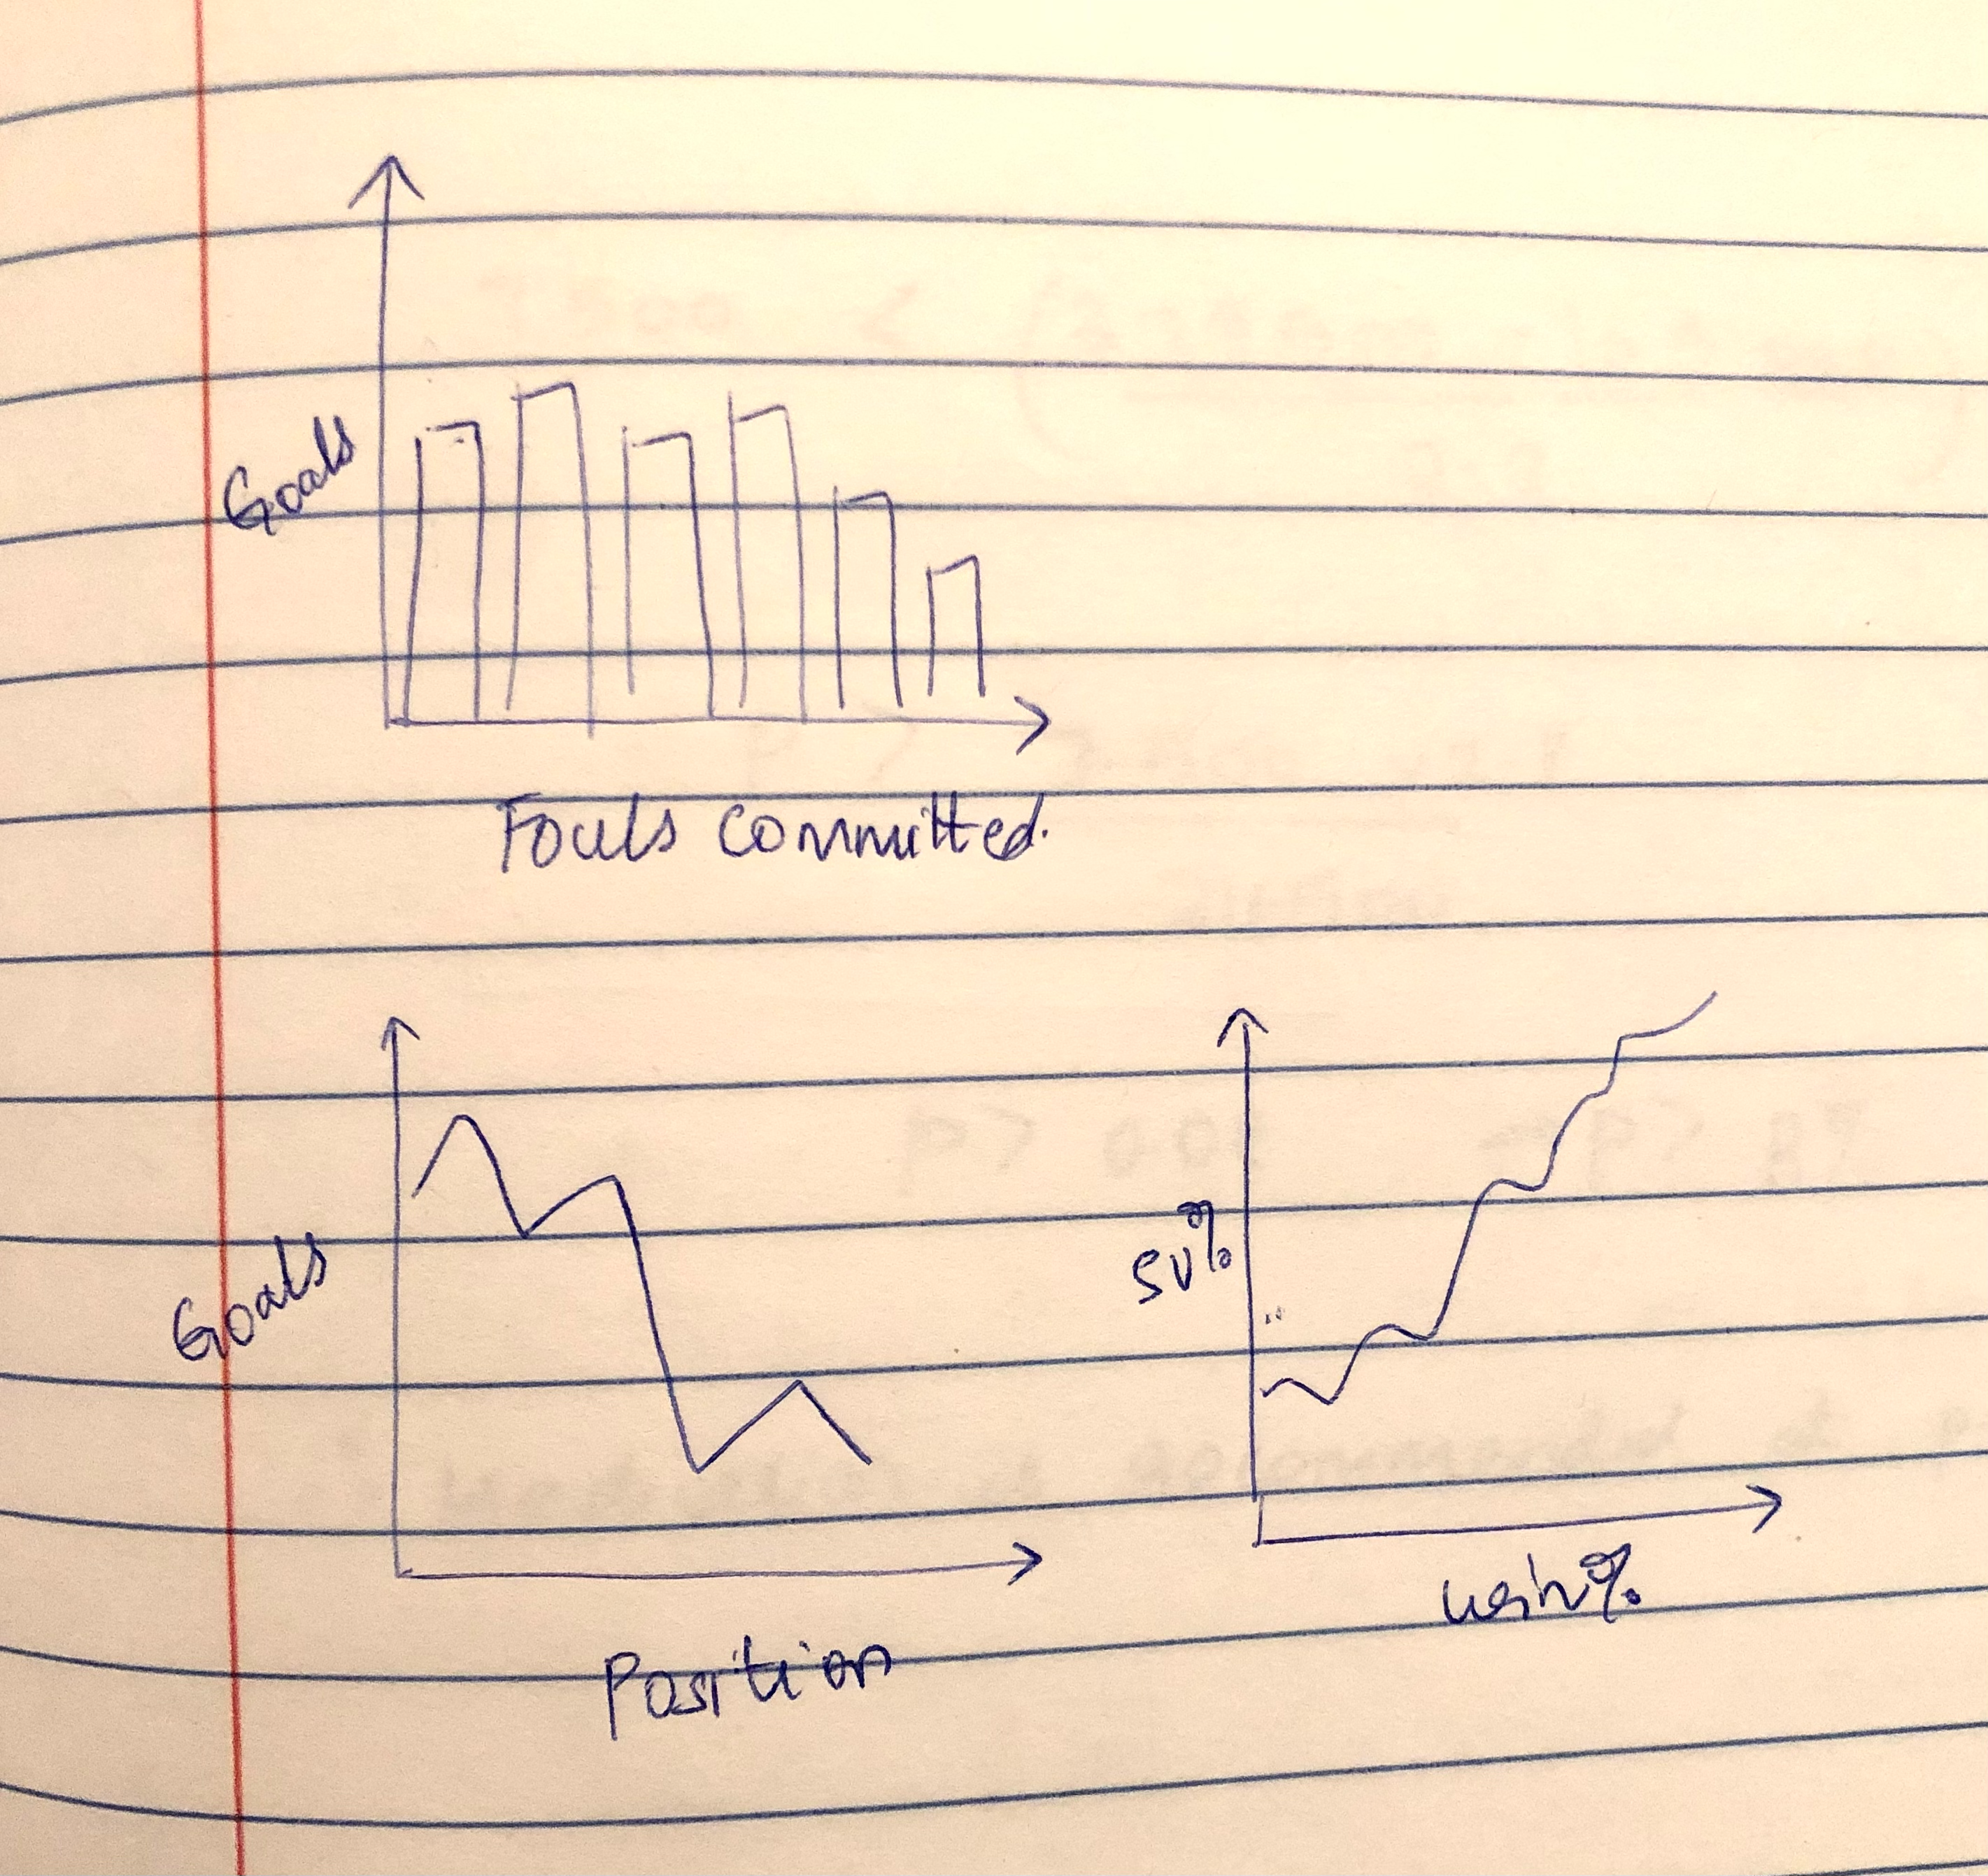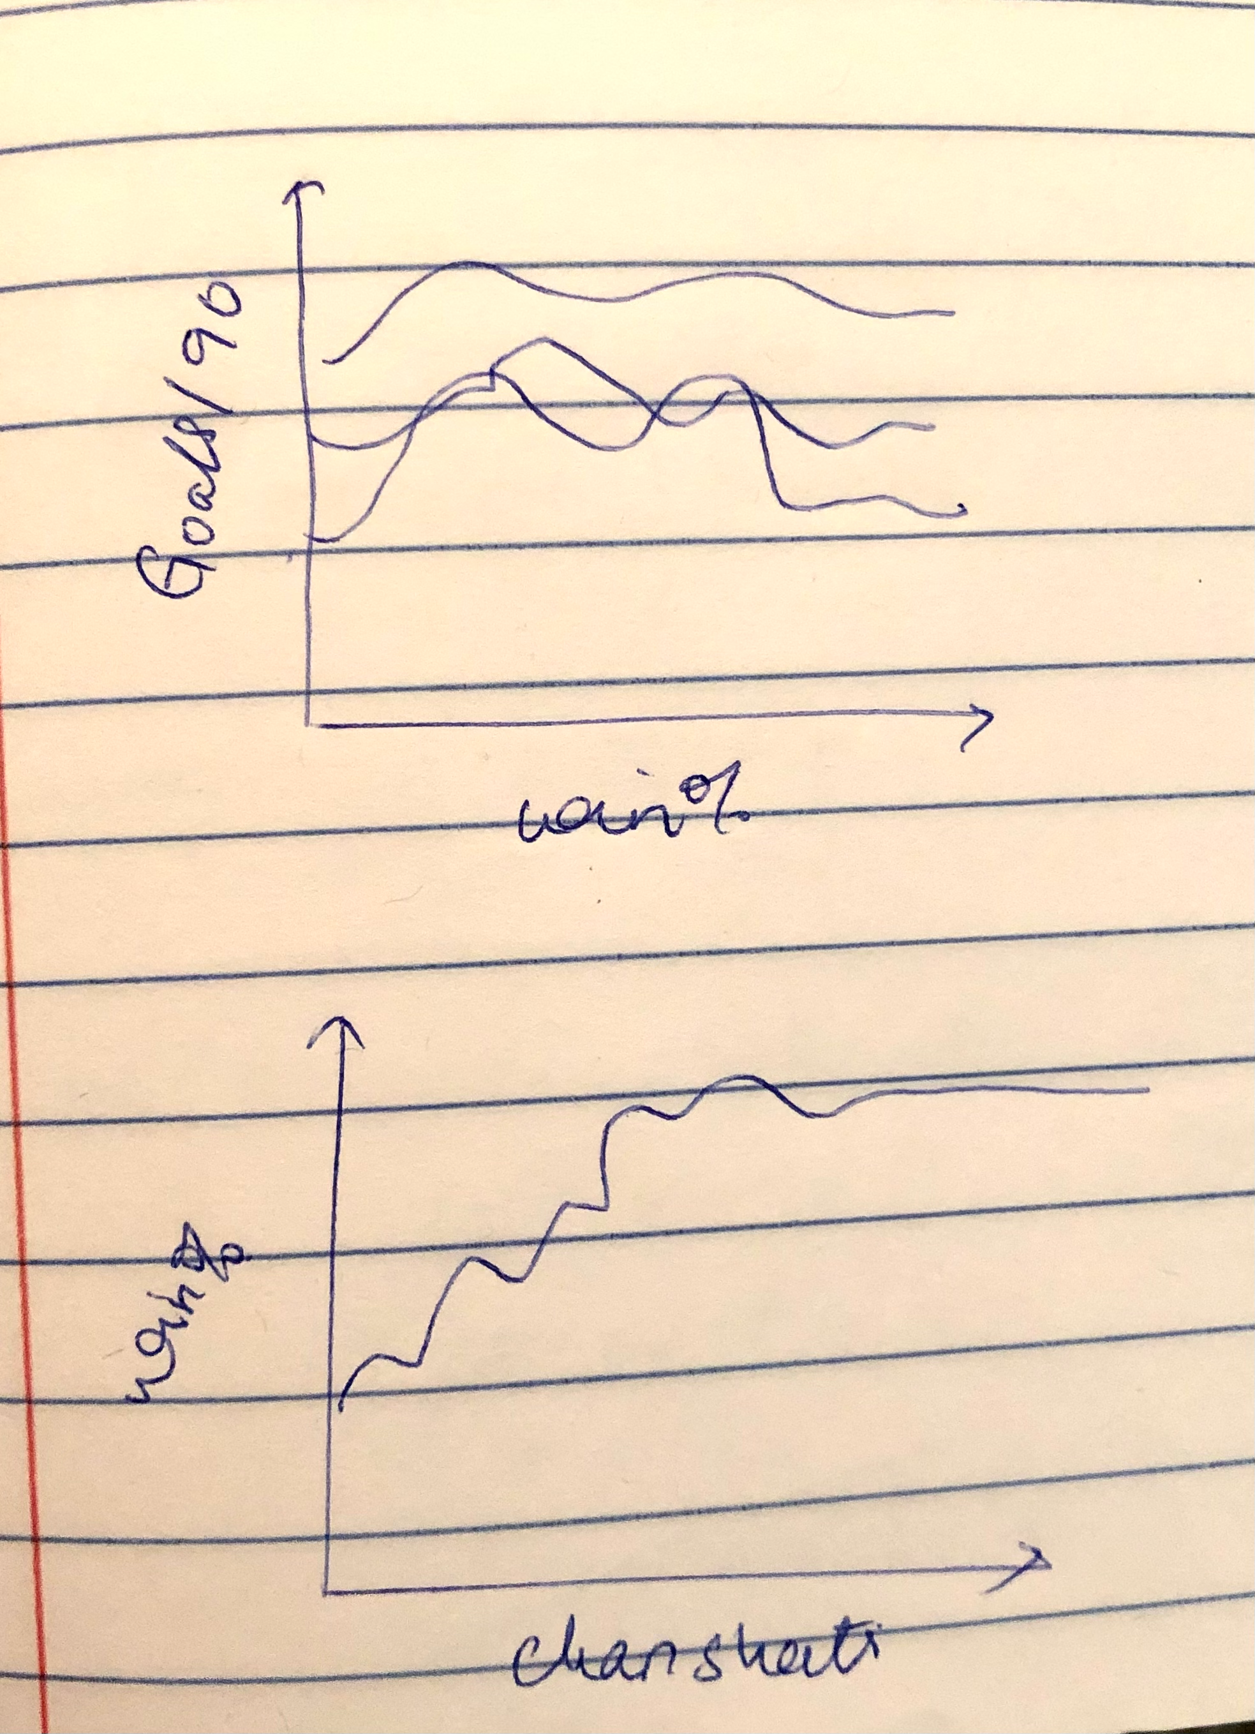

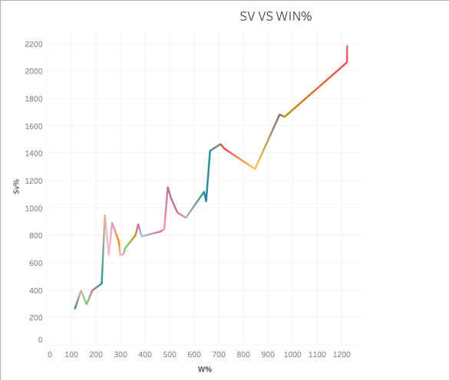

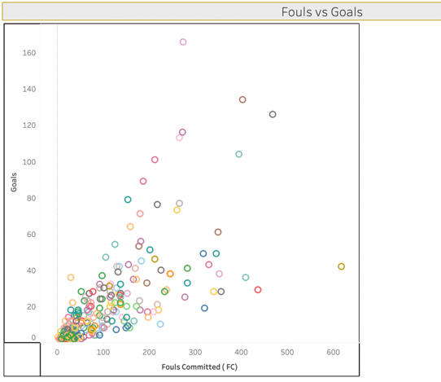

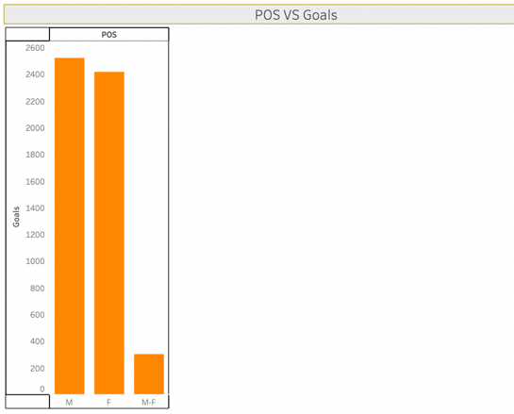

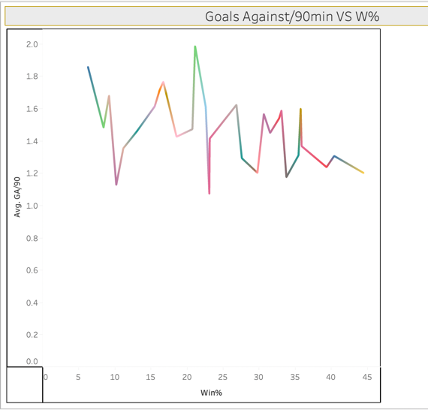

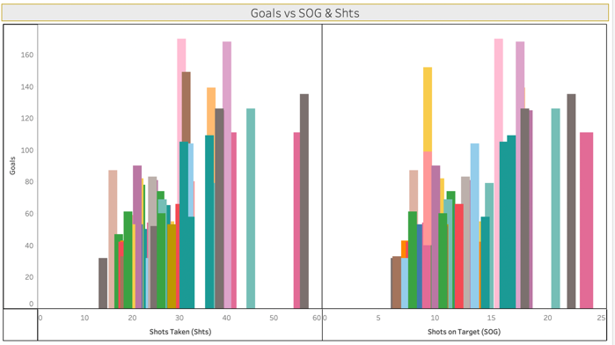

**Facts and questions**

Questions for goalkeeper dashboard:

1. Is there any relationship between number of saves made by the goalkeeper and win %.?
2. Similarly, what is the relationship between W % and goals against /90 min?
3. Can we say that more the number of clean sheets, greater is the W% or vice versa ?
4. So finally on the basis of the above factors, we can find the and also compare the win % of all the goalkeepers in the league so far.

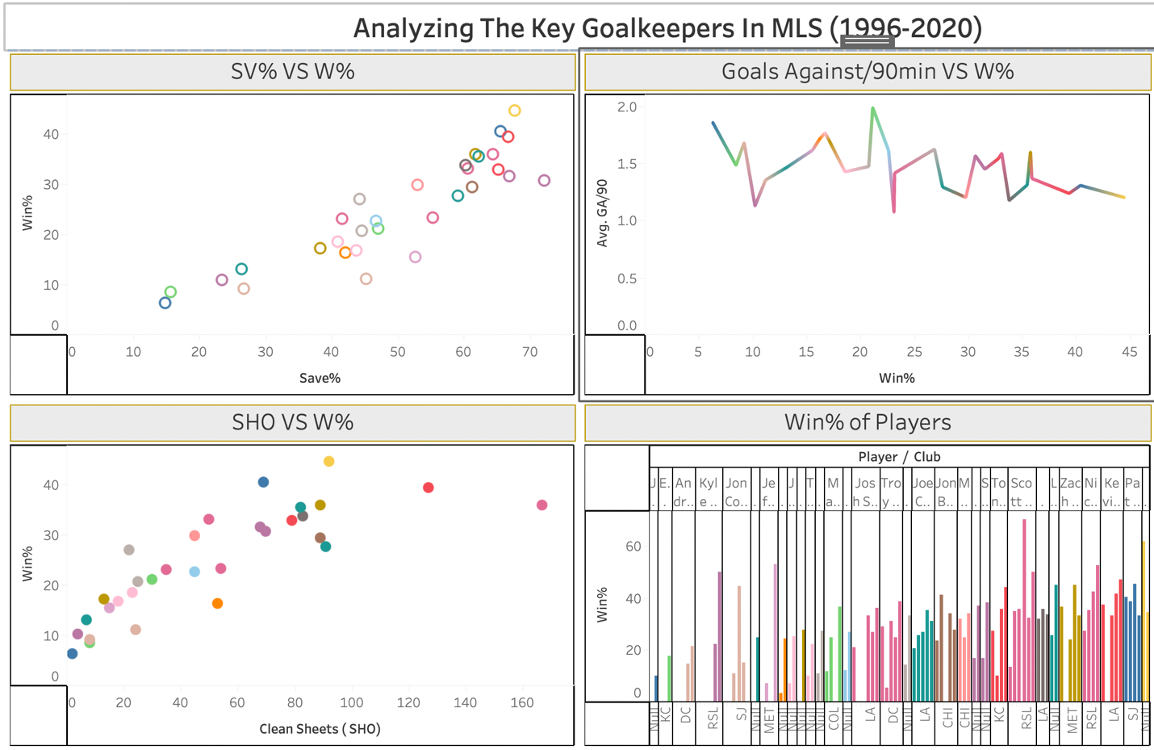

* **The save % vs Win % of all the players have been shows in the first scatter plot (Top left). These attributes have a linear relationship where both of these attributes are directly proportional.**
* **In the second graph represents a line graph between the Goals/90 and the Win%. The overall trend is decreasing with a few exceptions (spikes in both upwards and downwards direction)**
* **The Third graph represents the Clean Sheet vs Win% Scatter plot again. We could say that the relationship is exponential here.**

**We take an example of the player Stefan Frei below.**

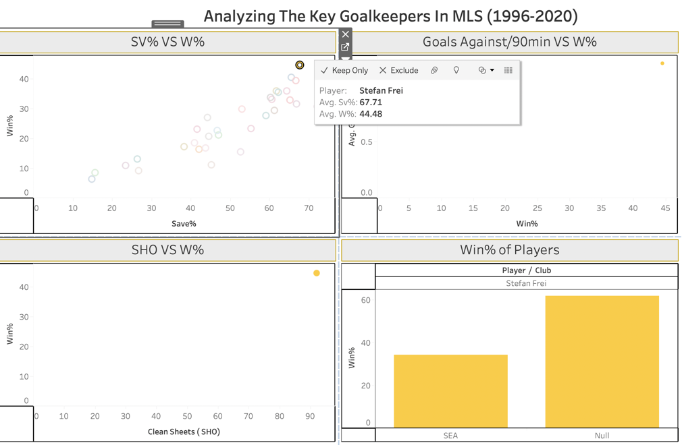

Stefan Frei

* The More saves, the more win%.
* Less goals conceded, more win
* More clean sheats , more win
* Here Stefan is a great example , he has more sv, less gaa and more clean sheets, therefore high w%

Questions for player’s dashboard:

Here we will see which factors affect the number of goals by a player

1. Is there any relationship between number of goals scored / 90 min and the position of the player -
2. Is there relation of number of goals scored / 90 min with

* Number of shots taken
* Number of shots on target

1. Relation between Goals/90 VS ASSISTS/90 - This is a scatter plot between the attributes - Goals/90 and Assists/90.
2. We display which player has scored the most number of goals.

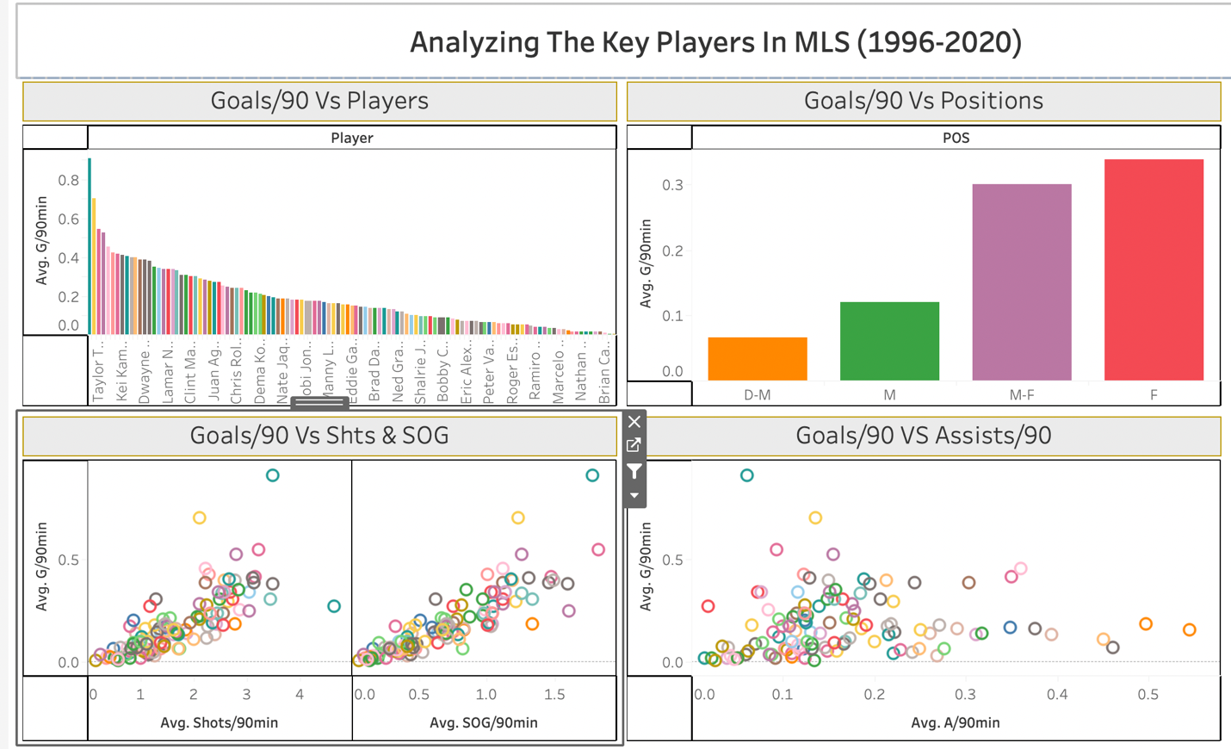

* Explain - The first graph represents Average number of Goals/90 and the players. Every player’s goals scored is displayed. The second bar graph (Top right) shows us the various positions of the player and Average Goals/90 - we see that the players ar Forward position have more chances of scoring more Goals. The graph on the bottom left represents Average Shots/90 and Avg Shots on Goal/90. Again like mentioned before, as the number of shots increase, the better chances of Shots on Goal and scoring a goal.

For a better understanding of the interpretation of the above graph, we take a player Carlos Ruiz.

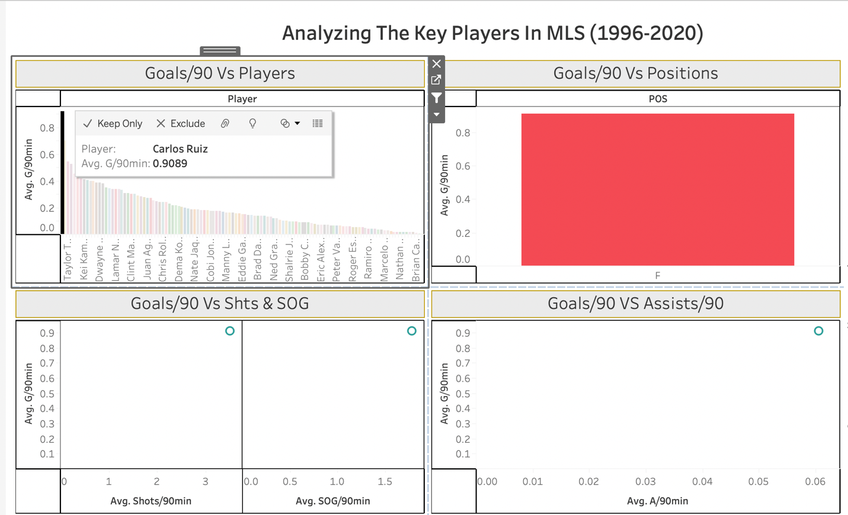

* Carlos Ruiz is an great example of a soccer player. We see that his avg Shots/90 is high and so is the SOG/90. He has a high Avg G/90 and Assista/90. As he scores more number of goals/90 we see that the position he is, in is the Forward position.